**Self-Correct Analysis**

***Hint: AP Progress Check Question #9 the variable should say “count” not “result”***

A) Paste your ***Test 3*** score from your **eiMACS** gradebook here. Ex:





B) Paste your ***AP Classroom Progress Check Unit 4 Part B MCQ*** here. Ex:

On the left panel, go to “My Reports”, “Progress Checks”

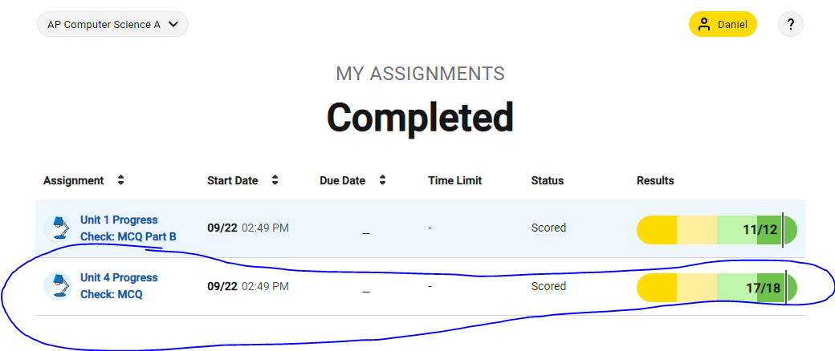

1. Answer the following questions for **EACH** multiple choice you answered ***INCORRECTLY***

a) Question number and topic?

Question 6 regarding the topic of for loops.

Question 12 on the AP Classroom Progress Check under the topic of Casting and Ranges of Variables.

b) What was the mistake or misunderstanding you had?

I wasn’t aware that for option II, the code adds j%10, for every iteration of j using all numbers from 0-num. To correct this, the final statement in the list comprehension would have to be changed to j/= 10, as all the other code segments have at some point in their code.

1. Now that you’ve reviewed all of your errors, what will you need to remember to be

successful with similar questions on the AP exam?

I will need to make sure I look at and evaluate each option thoroughly before answering. I should remember to analyze the differences between each loop thoroughly, and notice that all the other correct code segments divide their for loop variable by 10, except for code segment two.